zdroj: http://www.colourware.co.uk/cpfaq/q3-21.htm
The quantities L*, a*, and b* are obtained from the tristimulus values according to the following transformations:
L* = 116(Y/Y_{n})^{1/3} -16,
a* = 500[(X/X_{n})^{1/3} - (Y/Y_{n})^{1/3}],
b* = 200[(Y/Y_{n})^{1/3} - (Z/Z_{n})^{1/3}],
where X_{n}, Y_{n}, and Z_{n} are the values of X, Y, and Z for the illuminant that was used for the calculation of X, Y, and Z of the sample, and the quotients X/X_{n},Y/Y_{n}, and Z/Z_{n} are all greater than 0.008856. Note: When any of the quotients are less than or equal to 0.008856 a slightly different set of equations is used.

CIE 1976 (L* a* b*) colour space provides a three-dimensional representation for the perception of colour stimuli. If two points in space, representing two stimuli, are coincident then the colour difference between the two stimuli is zero. As the distance in space between two points (L*₁, a*₁, b*₁ and L*₂, a*₂, b*₂) increases it is reasonable to assume that the perceived colour difference between the stimuli that the two points represented increases accordingly. One measure of the difference in colour between two stimuli is therefore the Euclidean distance ΔE* between the two points in the three-dimensional space.
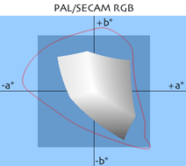
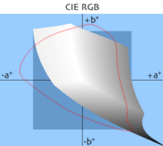
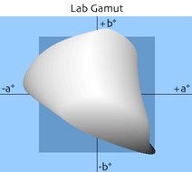

obr.: porovnanie gamutov (rozsahov zobraziteľnosti) známych sústav
